URL | Screenshot for studentadventuretours
http://travelandtourworld.blogspot.com/2016/11/webjet-partners-with-routehappy-to.html#comment-form | 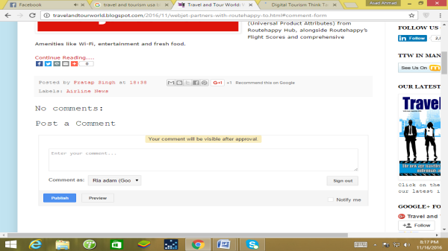
http://www.traveling-savage.com/2016/11/09/impressions-road-perthshire/#comment-119596 | 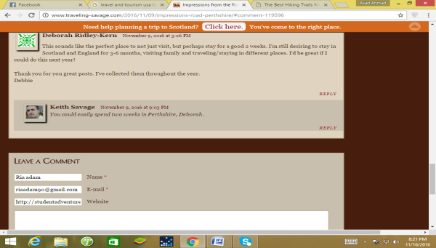
http://greenglobaltravel.com/2016/11/06/best-hiking-trails/#comment-262841 | 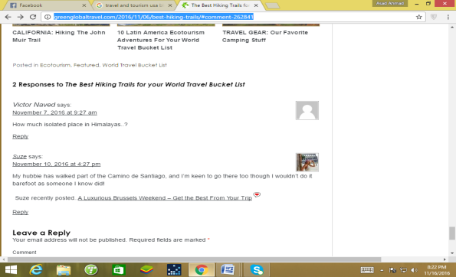
http://www.zencollegelife.com/50-best-north-american-travel-blogs/ | 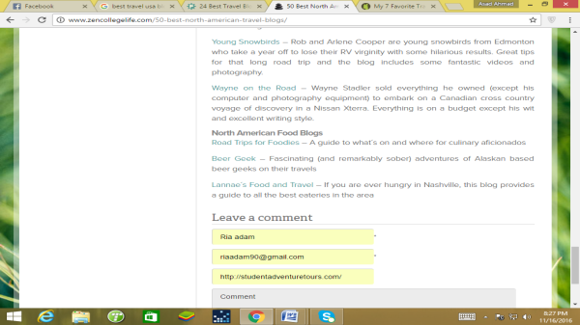
http://www.nomadicmatt.com/travel-blogs/best-blogs-of-2015/#comment-978893 | 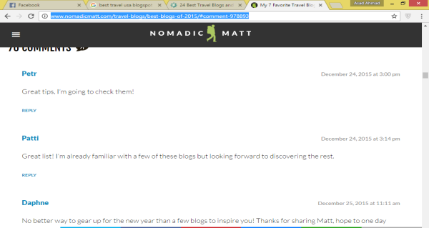
http://usa-roadtrips.blogspot.com/2010/01/intro.html#comment-form | 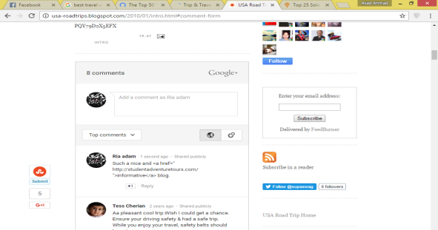
http://www.10best.com/awards/new-media-awards/best-budget-travel-blogger/
https://www.statravel.co.uk/travel-blog/2016/11/round-the-world-cape-town/#comment-194576 | 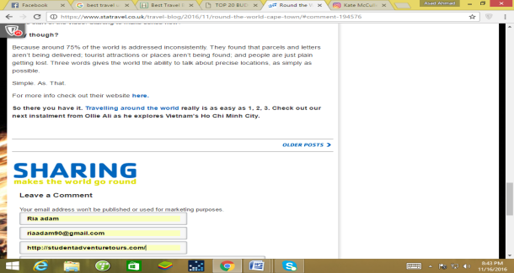
https://www.holidaylettings.co.uk/blog/top-20-budget-travel-bloggers-of-2015/#comment-83158 | 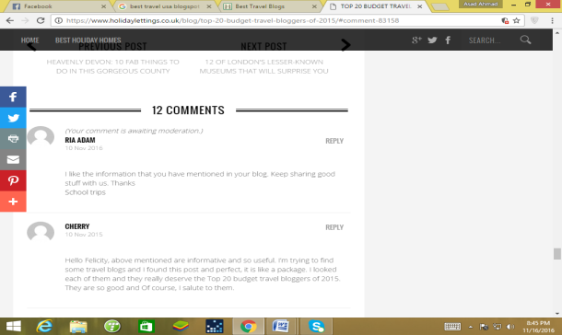
http://discovercorps.com/blog/best-baby-boomer-travel-blogs/#comment-5207 | 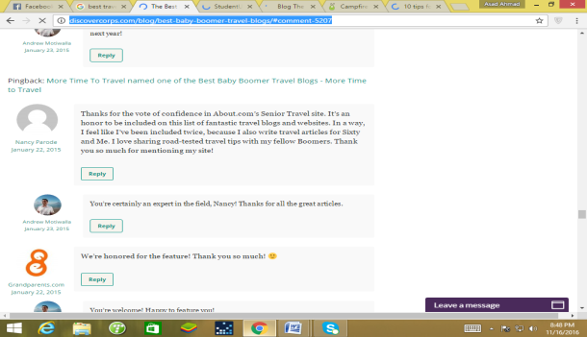
http://www.studentuniverse.com/blog/gap-year/3-places-worth-visiting-central-vietnam#comment-15910 | 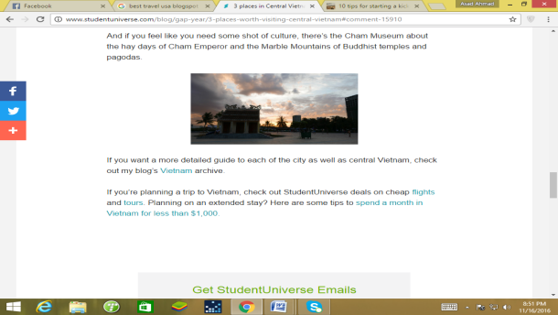
http://youngadventuress.com/2015/02/how-to-start-a-blog.html/comment-page-3#comment-369429 | 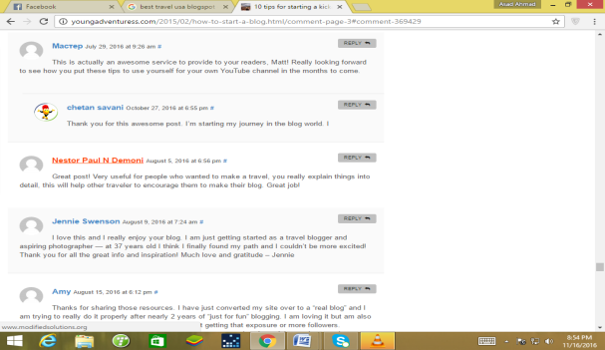
http://thetravelbite.com/podcast/ghost-stories-historic-haunts-of-jekyll-island-club/#comment-241783 | 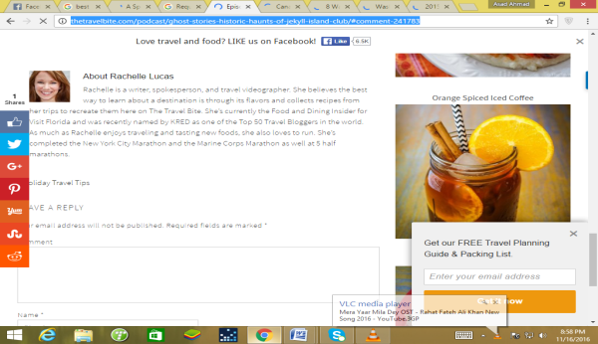
https://www.orbitz.com/blog/2015/12/look-ahead-10-hottest-gay-destinations-2016/#comment-754058 | 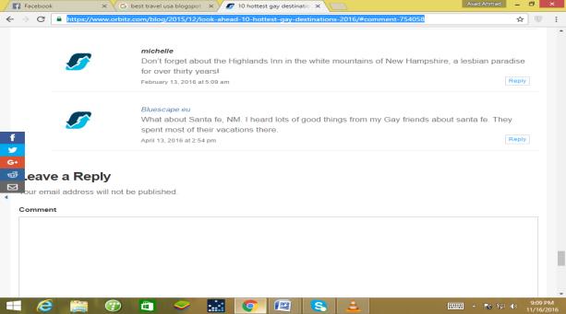
http://www.budgettravel.com/blog/deal-of-the-day-a-taste-of-historic-louisville-in-an-opulent-hotel-from-$159,68952/#commentsdiscussions | 